Kwantlen Park Secondary School Career Education 8 and 9

Career Education 8 and 9 Course Outline

Course Overview:
Career Education 8/9 offers students many opportunities to explore and develop personal interests, passions, and competencies while making connections with learning opportunities, and career and life path possibilities. Students will develop curricular competencies related to: Self-Discovery, Careers, Education, Finances, Health, and Emotional Well-being. The course lays the foundation for self- awareness, career exploration, and the beginnings of an integrated post-graduation plan presented in the form of a Capstone Project.

ALL students are required to complete the following Career Education courses over their Kwantlen Park Secondary School academic career in order to graduate.
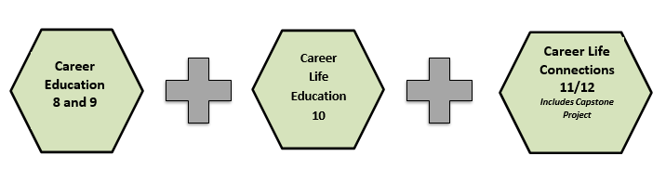

British Columbia Careers 8 and 9 Curriculum:

Big Ideas

Our attitudes toward careers are influenced by our view of ourselves as well as by our friends, family, and community.
Our personal digital identity forms part of our public identity. We must exercise digital citizenship.
Reflecting on our preferences and skills helps identify the steps we need to take to achieve our career goals.
The value of work in our lives, communities, and society can be viewed from diverse perspectives.
Achieving our learning goals requires effort, perseverance and flexibility. Learning is a life-long process that requires reflection and resilience.
Our personal choices, educational choices, and community involvement directly affects our possible career paths

Curricular Competencies

- Use self-assessment and reflection to develop awareness of their strengths, preferences, and skills
- Recognize the impact of personal public identity in the world of work
- Demonstrate respect, collaboration, and inclusivity in working with others to solve problems
- Recognize and explore diverse perspectives on how work contributes to our community and society
- Demonstrate safety skills and appreciate the importance of workplace safety
- Set and achieve realistic learning goals with perseverance and resilience
- Recognize the influence of curriculum choices and activities on career paths
- Appreciate the value of new experiences, innovative thinking and risk taking in broadening their career options
- Work towards developing a network of resources and mentors to assist with career exploration and appreciate their value
- Question self and others about the role of family expectations and traditions, and the influence of peers on career choices and attitudes toward work
- Apply a variety of research skills to expand their knowledge of diverse career possibilities and understand career clusters
- Apply decision-making strategies to a life, work, or community problem and adjust the strategies to adapt to new situations
- Develop public speaking skills for clear, engaging and professional communication

How is Career Education 8 and 9 Taught?

Grade 8 and 9 students will complete a series of lessons and assignments in each their core classes (English, Math, Science, Socials, Physical and Health Education) and the KPSS Career Centre will collect those assignments and report on the overall progress.
Each assignment and lesson will be taught by the subject teacher and marked by the teacher. Assignments are standalone and do not need to be completed in order. They need to be completed by the end of the first semester.

Grade 9 Take Our Kids To Work Day

Wednesday November 1, 2023 is Take Our Kids To Work Day. Grade 9 students are encouraged to attend work in a job shadow capacity that day with a parent, adult family member or adult family friend to gain an exposure to the working world and experience, for one day, what the real world looks like. Students who are unable to arrange a work placement will attend classes as per the normal KPSS schedule and work on an alternate assignment for course credit.

Assignments:

Career Education 8:

- Assignment 1: How I view myself, How others view me
- Assignment 2: Who do I want to be?
- Assignment 3: What kind of citizen do I want to be?
- Assignment 4: Choosing the Right Volunteer for the Surrey Food Bank
- Assignment 5: My Grade 8 Time Capsule

Career Education 9:

- Assignment 1: Take Our Kids To Work (Students complete one of two assignments depending on whether they attended a workplace on Take Our Kids to Work Day-November 1, 2023)
- Assignment 2: Employability Skills
- Assignment 3: Volunteering
- Assignment 4: Employment Recruiter
- Assignment 5: Goal Setting

